DAFCGOC
Welcome Guide for Base CGOCs
CAO: February 2026

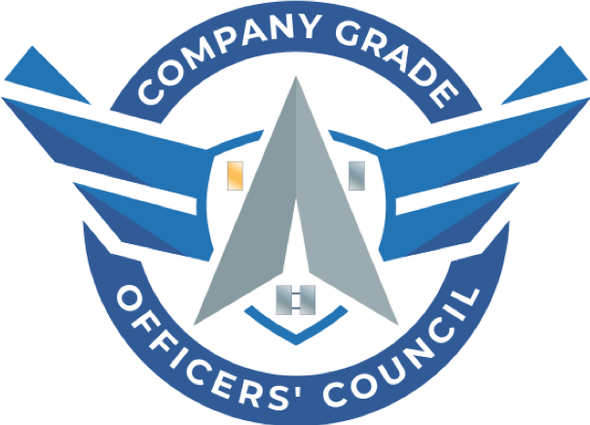

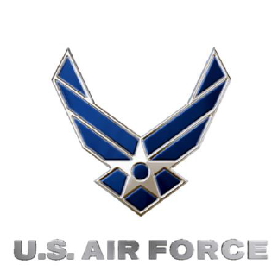

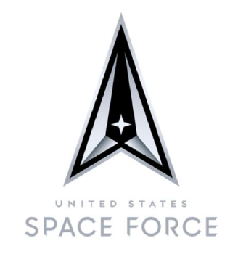


Mission Statement: The Dept. of the Air Force Company Grade Officers' Council connects base councils globally to grow and develop leaders by leveraging Department of the Air Force resources to build a robust community of Lieutenants and Captains.

Vision Statement: To empower councils at Air Force and Space Force units around the world through Advocacy, Recognition and Communication to the regions down to the base-level. The DAFCGOC will coordinate and disseminate training materials and deliver the pulse of the CGO from its constituent councils to senior military leadership.
https://dafcgoc.org/
DAFCGOC Organizational Structure:
The DAFCGOC operates in a three-tier structure to fulfill the mission of the DAFCGOC. The DAFCGOC oversees over 100+ local base CGOCs across the DAF.
Tier 1: Executive Council:
- Chairman & Vice Chairman: Oversees DAFCGOC:
  - Ensures mission execution.
  - Face with Senior Advisor. Briefs on DAFCGOC projects, goals, programs to include Awards program.
  - Special Projects:
    - Chairman: AFA CGOC Networking Event.
    - Vice Chairman: DAFCGOC “Penpal” Program
- Treasurer: Oversees all financial aspects for DAFCGOC:
  - Bank account.
  - Funding requests.
  - Manage Zeffy Storefront/ DAFCGOC Swag sales & donations.
- Director of Staff: Oversees administrative matters and positional goals:
  - Manages administrative systems and secretary functions.
  - Ensure all positions are meeting goals in a timely and qualitative manner. Will conduct syncs for check ins with all positions.
  - Special Projects:
    - DAFCGOC FTOC Program (intent to partner with Air University)
Tier 2: Region Directors (RDs):
- Eastern Region Director: Councils East of Mississippi:
  - Oversees 27+ bases.
  - TEAMS Page: https://dod.teams.microsoft.us/l/team/19%3Adod%3AhS9FlkiMmGqjrBtSez4N8fK1QgPFKvCDrYPBr9GpGBI1%40thread.tacv2/conversations?groupId=411676c5-7e8a-42d2-927f-d8c06e9d26a7&tenantId=8331b18d-2d87-48ef-a35f-ac8818ebf9b4
- Western Region: Councils West of Mississippi:
  - Oversees 40+ bases.
  - TEAMS Page: https://dod.teams.microsoft.us/l/team/19%3Adod%3A3834926ebb1c4612999d713925da5e2c%40thread.tacv2/conversations?groupId=f9520402-94e0-4c5f-bb5b-505935807697&tenantId=8331b18d-2d87-48ef-a35f-ac8818ebf9b4
- European Region: Council in Europe and Middle East:
  - Oversees 10+ bases.
  - TEAMS Page: https://dod.teams.microsoft.us/l/team/19%3Adod%3Add1edb17bf734c33ab832af367b6b997%40thread.tacv2/conversations?groupId=a7bed95b-b33d-4c3f-9c33-7cf5e64894c5&tenantId=8331b18d-2d87-48ef-a35f-ac8818ebf9b4
- Pacific Region: Councils in Pacific:
  - Oversees 9+ bases.
  - TEAMS Page: https://dod.teams.microsoft.us/l/team/19%3Adod%3A6269b0651de243a5bc5f2d8f190a8c8f%40thread.tacv2/conversations?groupId=f9a573c8-7def-4bcb-9784-08e2022a8bf1&tenantId=8331b18d-2d87-48ef-a35f-ac8818ebf9b4
- What Your RD will do for you:
  - Funnels information, resources, opportunities from DAFCGOC level down to bases.
  - Maintains accountability of base CGOC presidents and vice presidents. It is important for you and your council to maintain contact with your RD to ensure proper turnover.
  - Submit all DAFCGOC awards to your RD. Your RD will provide you with submission due date for quarterly and annual awards.
  - Your RD is your main POC between your council and the DAFCGOC!
Tier 3: Committee Directors:
- Professional Development:
  - Provides resources, trainings, SOPs, startup materials to base level councils.
  - Works hand and hand with Communication Director to push materials out via social media platforms.
- Communications Director:
  - Social Media guru.
  - Provides trainings to base CGOCs looking to use social media to promote local CGOC opportunities and events.
  - Pushes all opportunities from Ex Council down.
  - Fills the gaps between bases without councils and those that do.
- Technology Director:
  - Manages website which is our key information source/hub.
  - Provides trainings to base CGOCs looking to standup website/sharepoint.
Senior Advisor and Mentors:
- Senior Advisor:
  - Endorses DAFCGOC operations.
  - Signs off on Awards Program.
- Chairman Emeritus:
  - Past DAFCGOC Chairmen.
  - Mentors current DAFCGOC officers.

DAFCGOC Awards Program:
The DAFCGOC quarterly and annual awards program serves to foster teamwork and esprit de corps for the base level CGOCs. The DAF CGOC’s awards program recognizes superior performance of base level CGOCs and leaders. It applies to all USAF and USSF Active Duty, Guard, and Reserve CGOs in the DAF. It implements DAFPD36-28, Awards Program and DAFMAN 36-2806, Awards and Memorialization Program.
The awards template can be found on our website under the resource tab or provided to you by your RD (https://dafcgoc.org/).

Base CGOCs shall submit awards to RDs by:
Award | Award Period | Due to RD
1Q | 1 Jan – 31 Mar | 10 Apr
2Q | 1 Apr – 30 Jun | 10 Jul
3Q | 1 Jul – 30 Sep | 10 Oct
4Q | 1 Oct – 31 Dec | 10 Jan
Annual | 1 Jan – 31 Dec | 10 Jan

Quarterly Winners: Quarterly winners will receive the DAFCGOC Coins Package:
- Coins Sent:
  - DAF CGOC - 4x Coins for the Base CGOC President, Vice President, Treasurer, and Secretary
  - DAF CGO Leader - 1x Coin for CGO Leader
- DAF CGOC Senior Advisor Letter
- DAF CGOC Chairman Letter

Annual Winners: Annual winners may be eligible to receive the Air and Space Recognition Ribbon.
DAFCGOC Resources:
There are several DAFCGOC produced resources to help you establish or build your council.
Our resources page offers the below materials and some more as well. Website: https://dafcgoc.org/:
- Base CGOC Startup Manual
- Base CGOC Constitution and Bylaws Template
- Base CGOC Lessons Learned
- First Term Officer Course (FTOC) SOP and course resources. Training is also provided to local bases looking to startup a FTOC program.
  - There is also a DAFCGOC FTOC Teams channel where the FTOC resources are located and where you can collaborate across the DAF - General | DAFCGOC FTOC Program | Microsoft Teams
- PD/fundraising ideas
- We have recently partnered with the Developing Future Enlisted Officers (DEFO) team if your base is looking to establish a formal E to O mentorship program (more info attached)

DAF CGOC Store Front: https://dafcgoc.org/pages/store.html

The DAF CGOC is now selling swag! Your contributions play an important role in allowing the DAF CGOC promote professional development opportunities and build like-minded leaders across the DAF.
Your investment will help support programs and services for the DAFC GOC and base CGOCs.

Follow us on Social Media!

Website | LinkedIn | Facebook | Instagram | YouTube

Email us at: nationalcgoc@gmail.com

